

**SKEL4273 CAD WITH HDL (01)**

**ASSIGNMENT 5 & 6 - Digital Calculator**

**GROUP NAME : J.E.M.**

**GROUP MEMBERS: 1. LEONG GUANG YE (A17KE0085)**

**2. CHAN PEI TING (A17KE0046)**

**3. JOYCE NG TING MING (A17KE0077)**

**COURSE : 4SKEL**

**LECTURER : PM. MUHAMMAD MUN’IM BIN AHMAD ZABIDI**

**Algorithm of Digital Calculator in C Language**

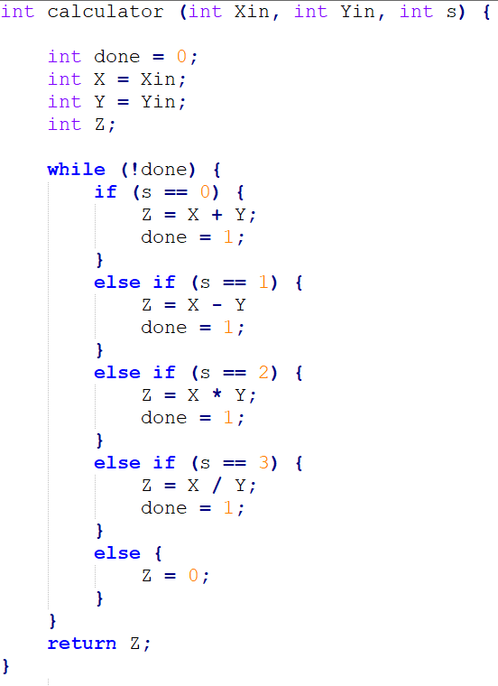

**rtl-ASMchart of the Digital Calculator**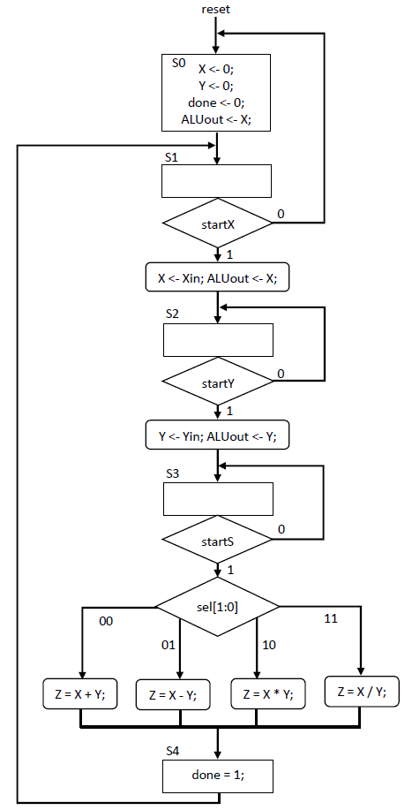

**FBD of Datapath Unit (DU) of the Digital Calculator**

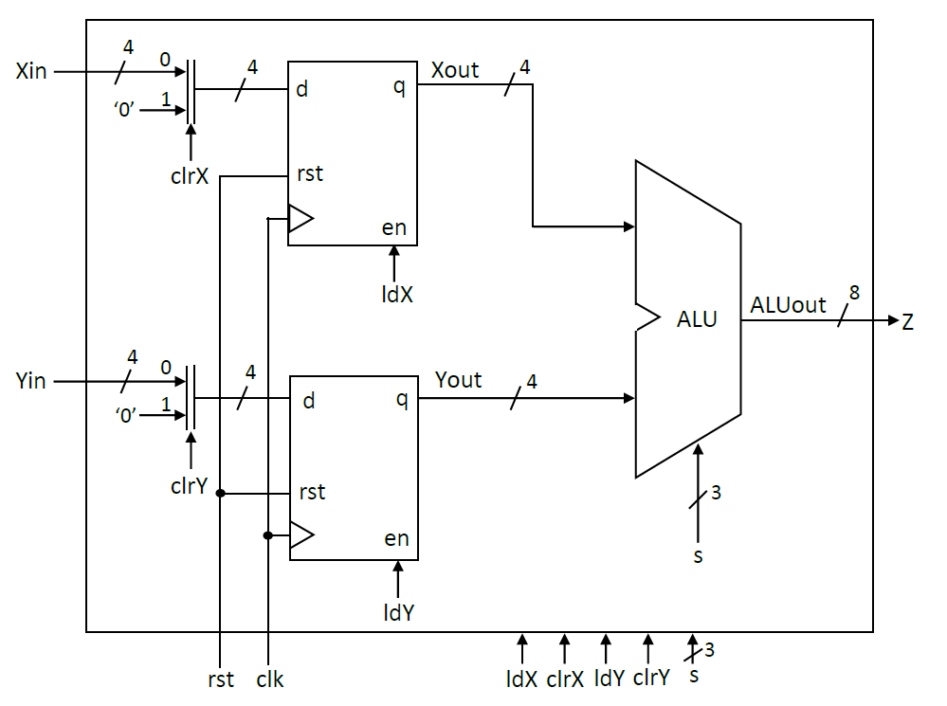

**Verilog Code of Datapath Unit (DU)**

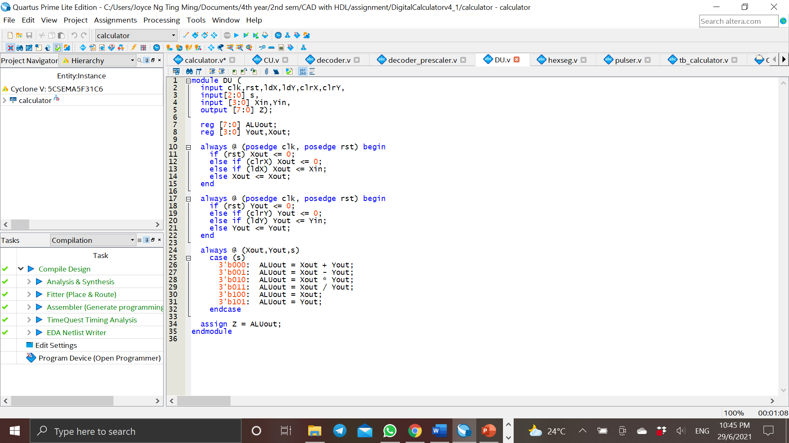

**FBD of Control Unit (CU) of the Digital Calculator**

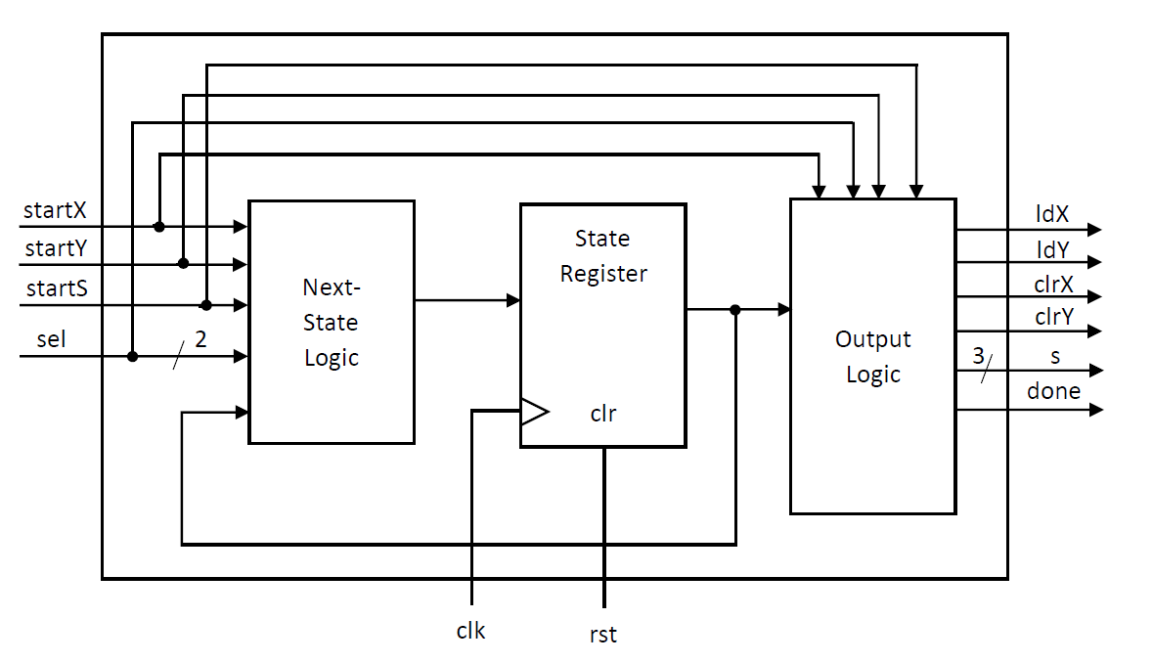

**RTL-CS Table of Digital Calculator**

|  |  |
| --- | --- |
| **RTL-code** | **Control signals activated**  **ldX ldY clrX clrY s2 s1 s0 done** |
| **S0: done = 0; X <- 0; Y <- 0; ALUout <- X;** | **clrX clrY s2 s1* s0\*** |
| **S1: (startX) / X <- Xin; ALUout <- X;**  **(startX) / goto S2: goto S0;** | **ldX s2 s1* s0\*** |
| **S2: (startY) / Y <- Yin; ALUout <- Y;**  **(startY) / goto S3: goto S2;** | **ldY s2 s1* s0** |
| **S3: (startS && sel == 2’b00) / Z = X + Y;**  **(startS && sel == 2’b01) / Z = X - Y;**  **(startS && sel == 2’b10) / Z = X * Y;**  **(startS && sel == 2’b11) / Z = X / Y;**  **(startS) / goto S4: goto S3;** | **s2* s1* s0\***  **s2* s1* s0**  **s2* s1 s0\***  **s2* s1 s0** |
| **S4: done = 1;**  **goto S1;** | **done** |

**ASMchart**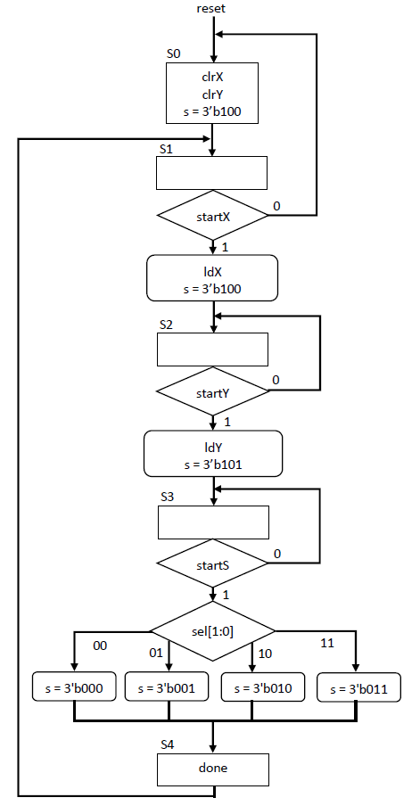

**Verilog Code of Control Unit (CU)**

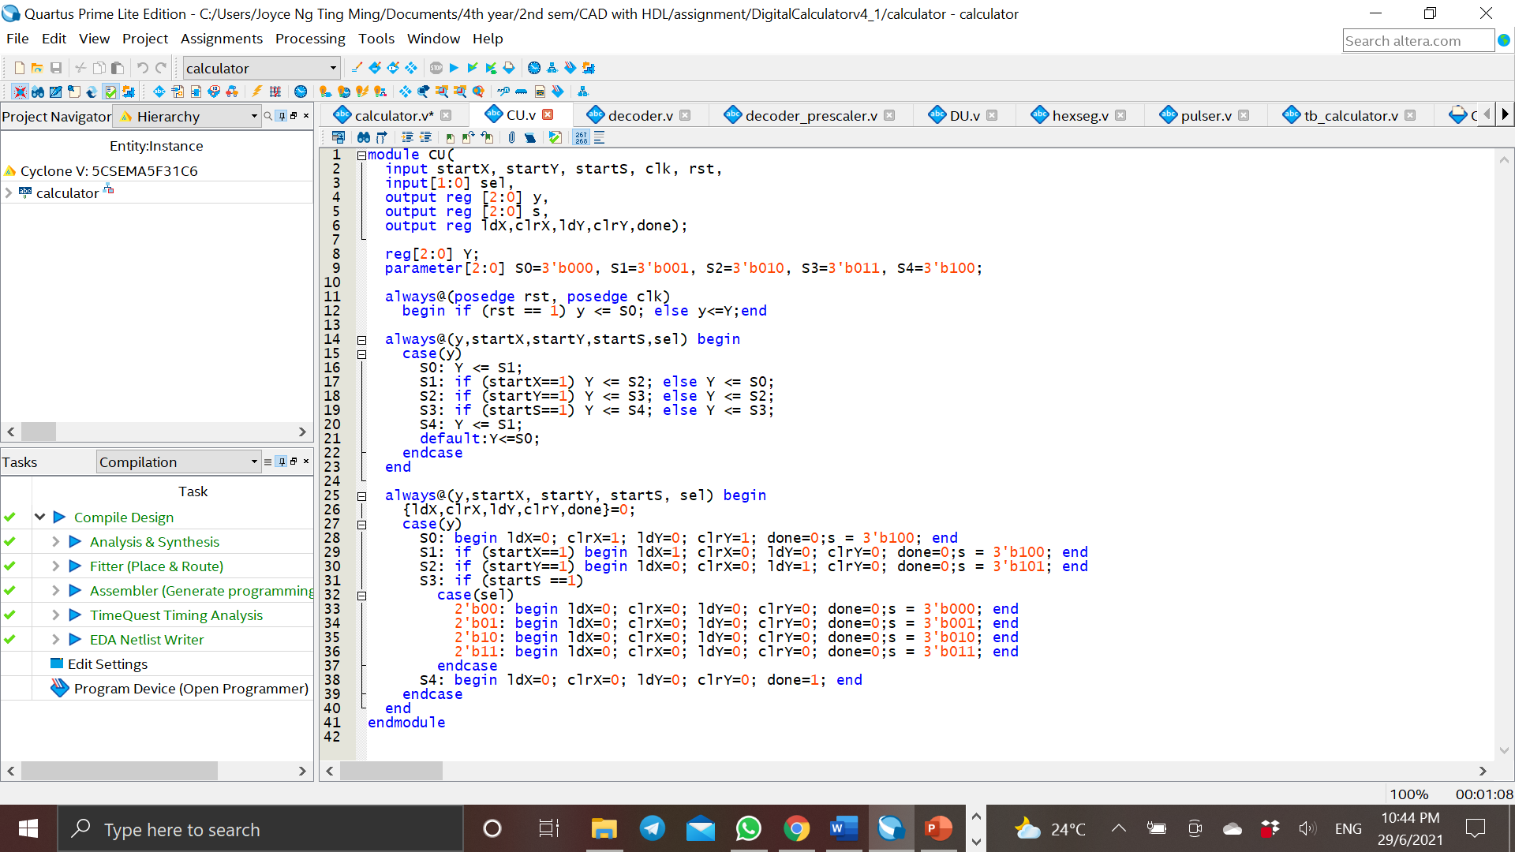

**FBD of Top-level Module of the Digital Calculator**

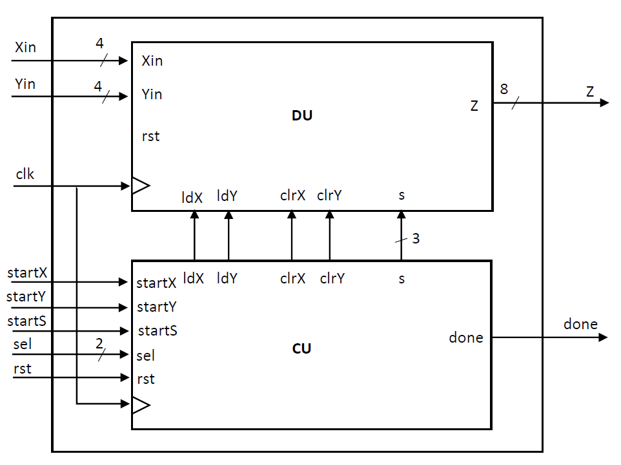

**IOBD of Connection of Digital Calculator with Keypad**

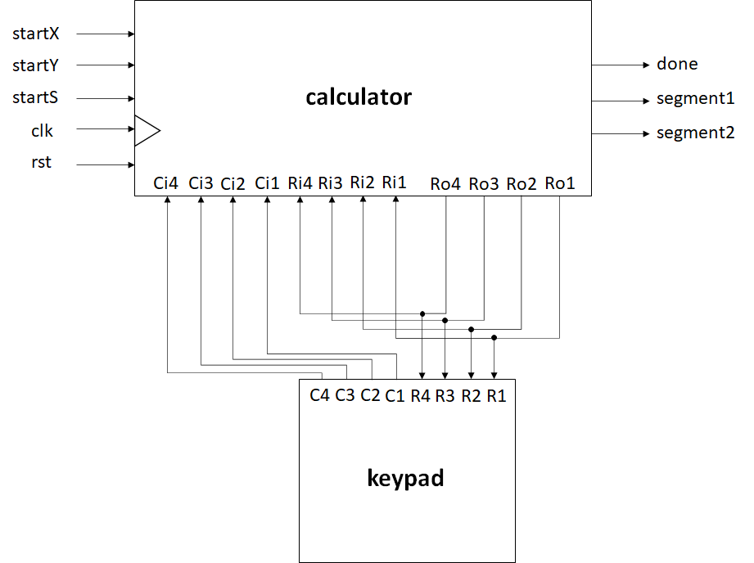

**Verilog Code of Top-level Module (Digital Calculator)**

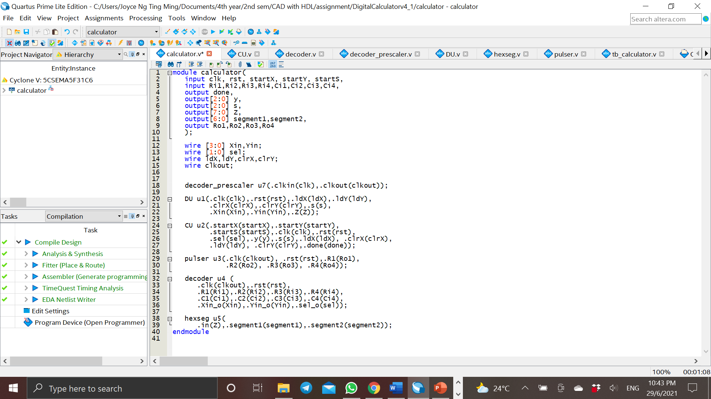

**Verilog Code of 4x4 Matrix Keypad Decoder** 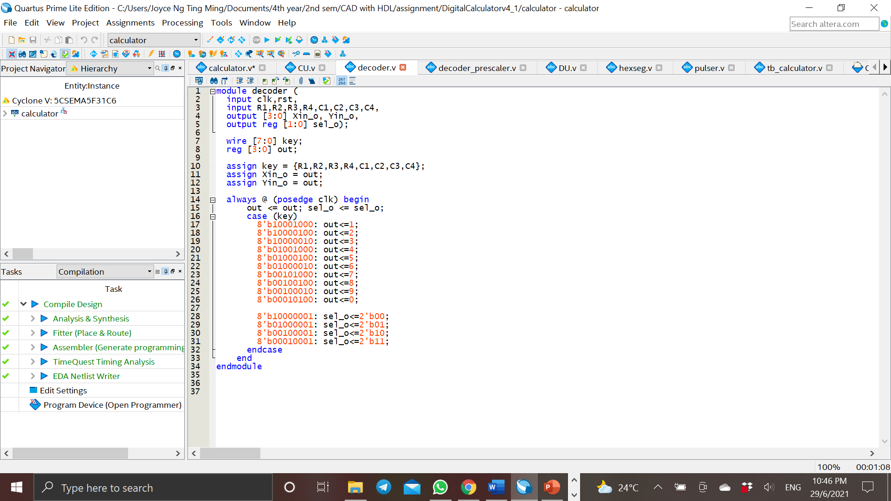

**Verilog Code of Pulser**

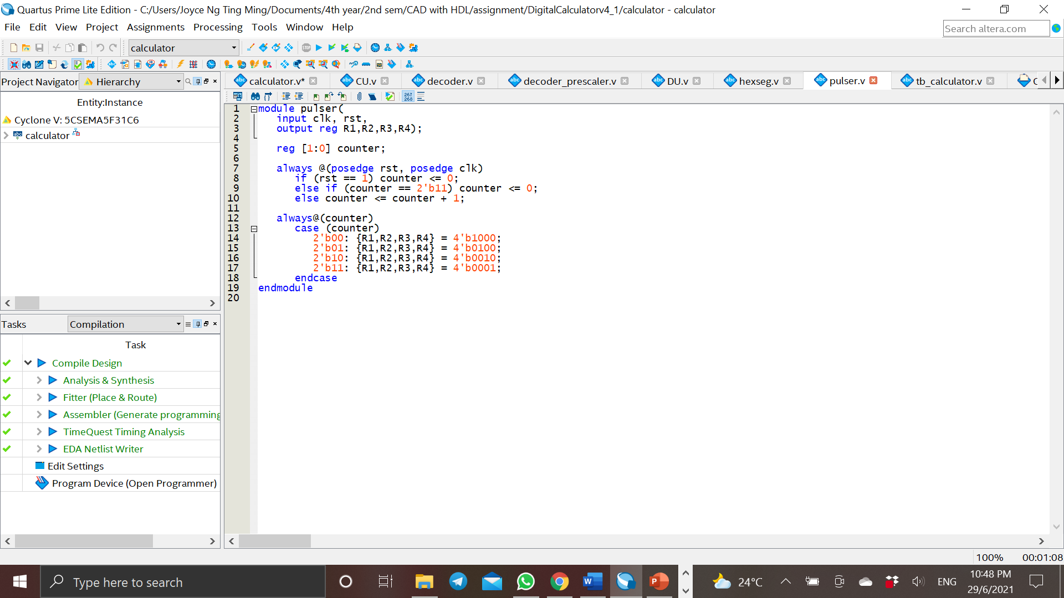

**Verilog Code of Prescaler of the Digital Calculator**

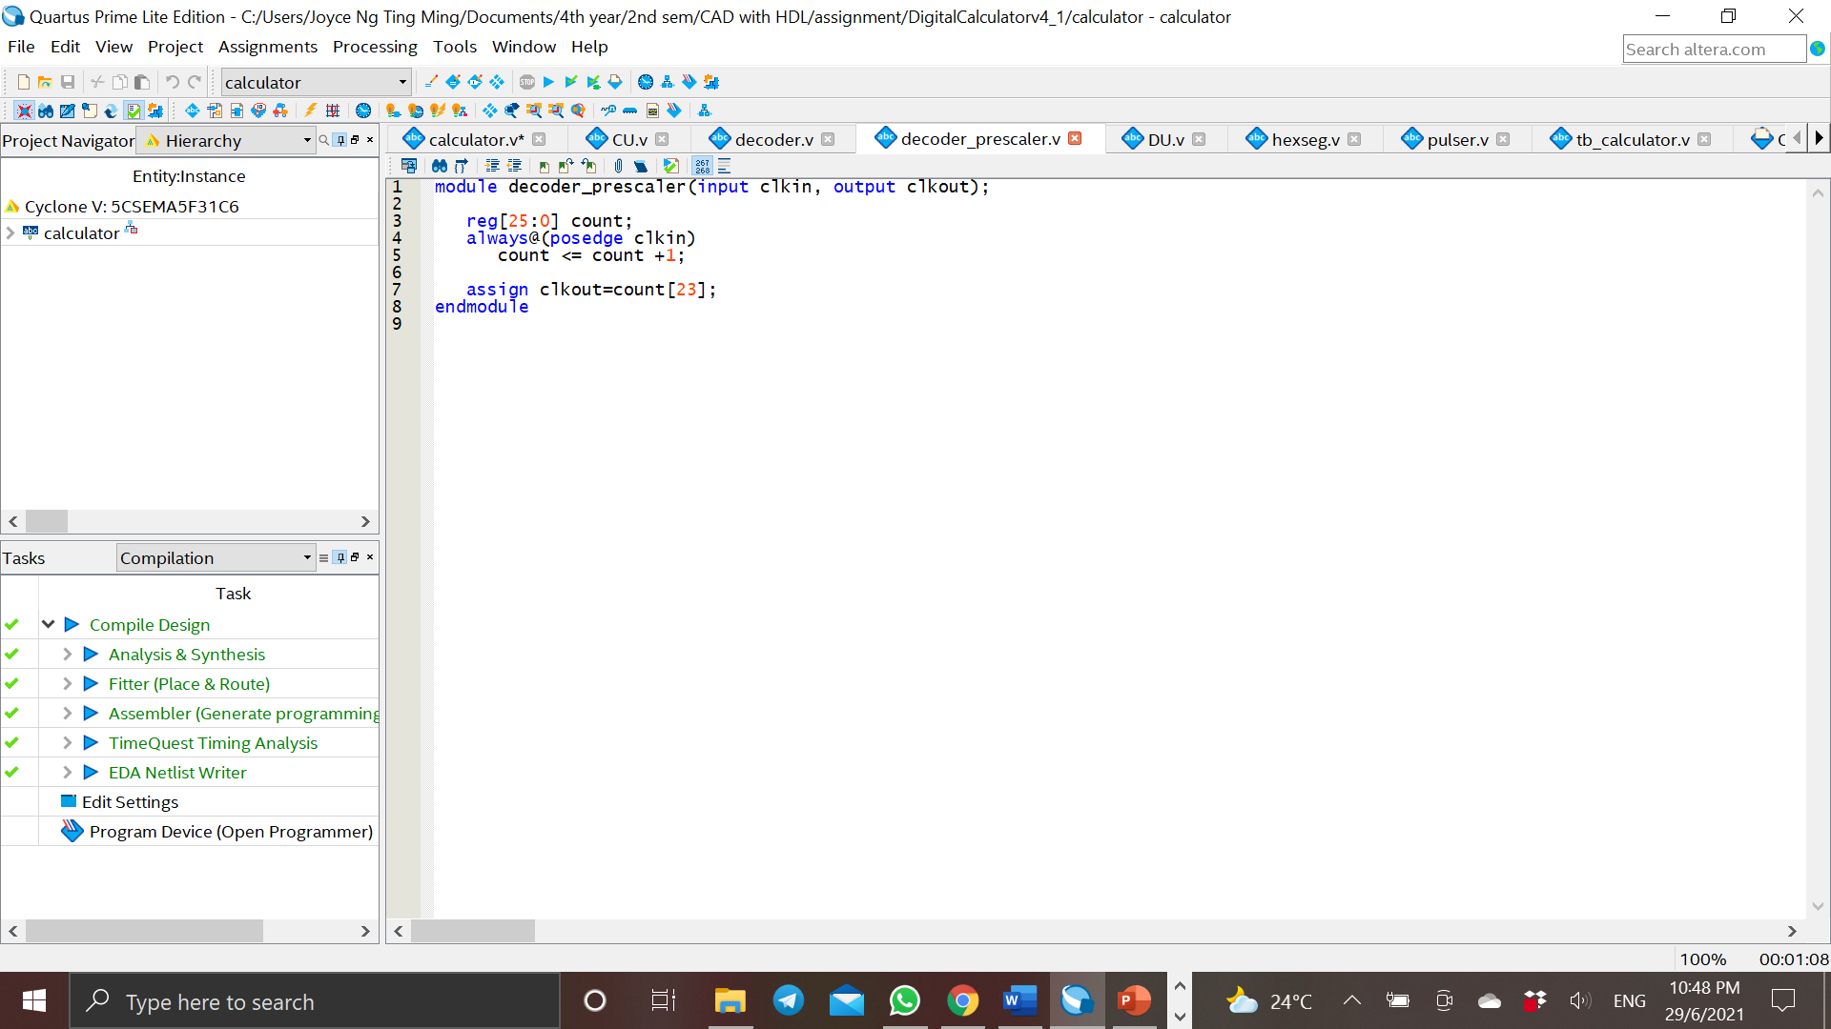

**Verilog Code of Hexadecimal to 7-segment Decoder of the Digital Calculator**

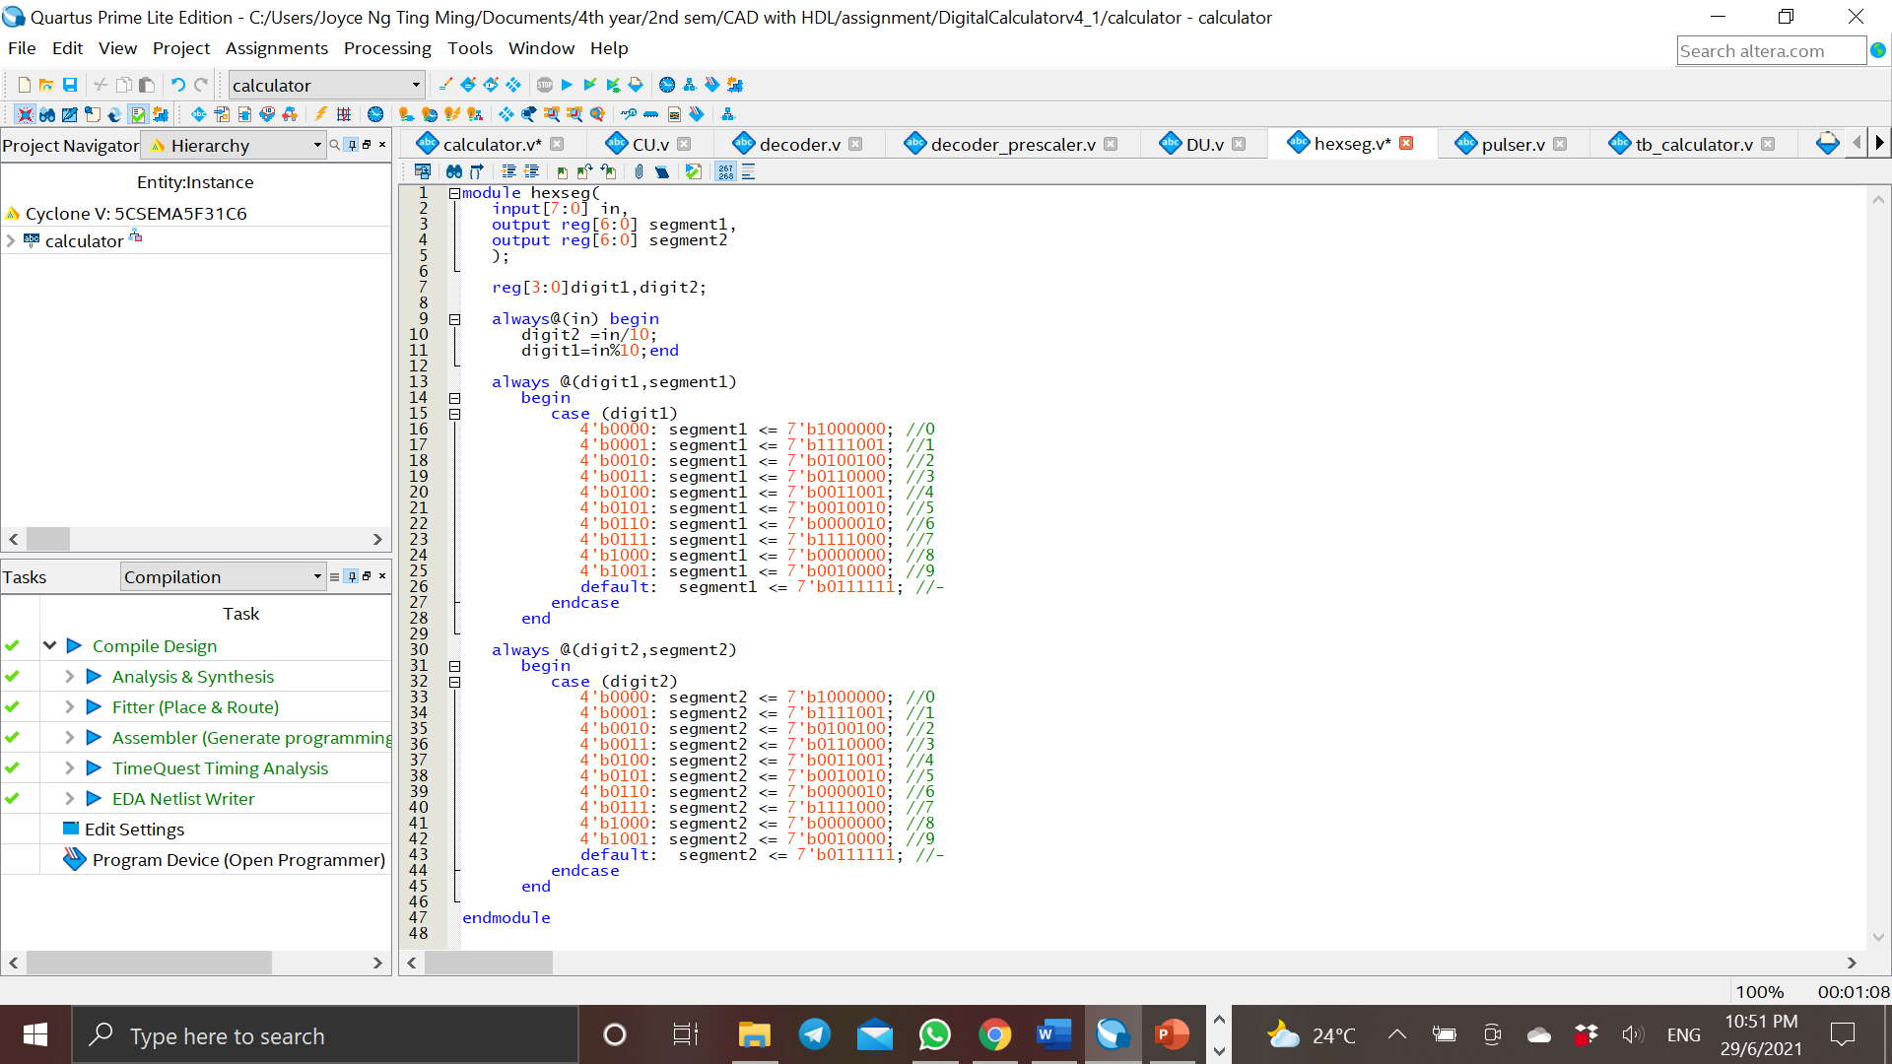

**Testbench**

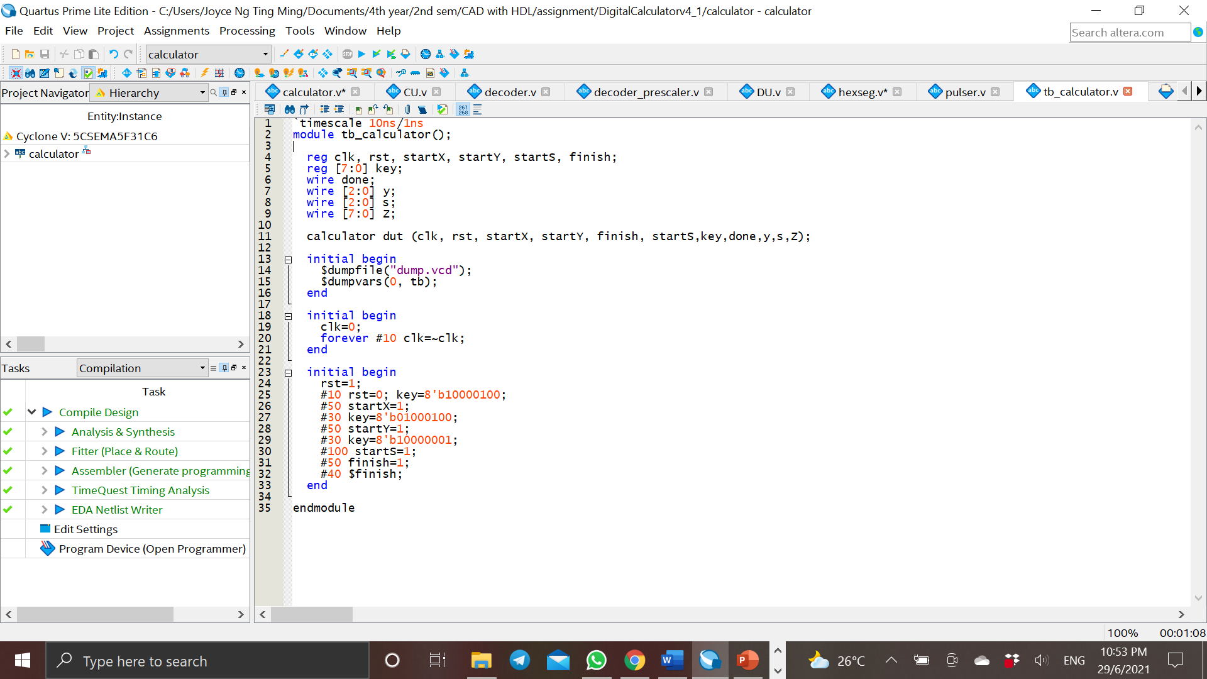

**Simulation Report & Waveform**

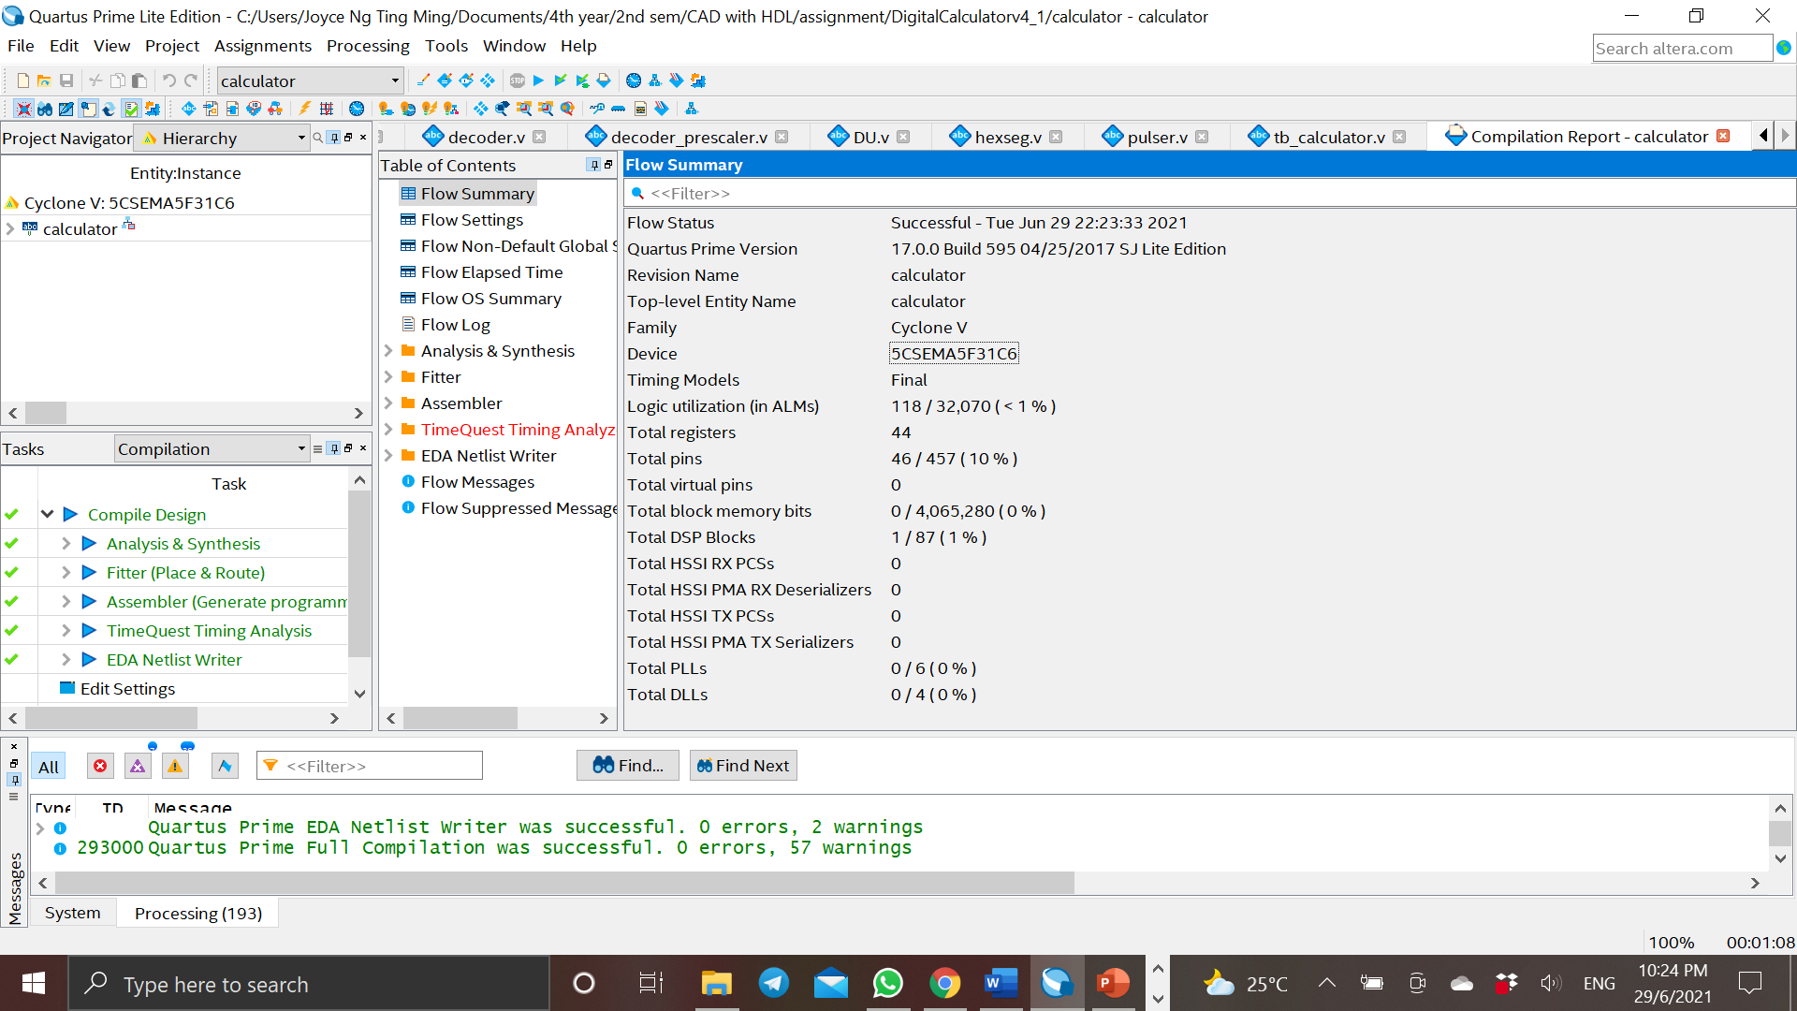

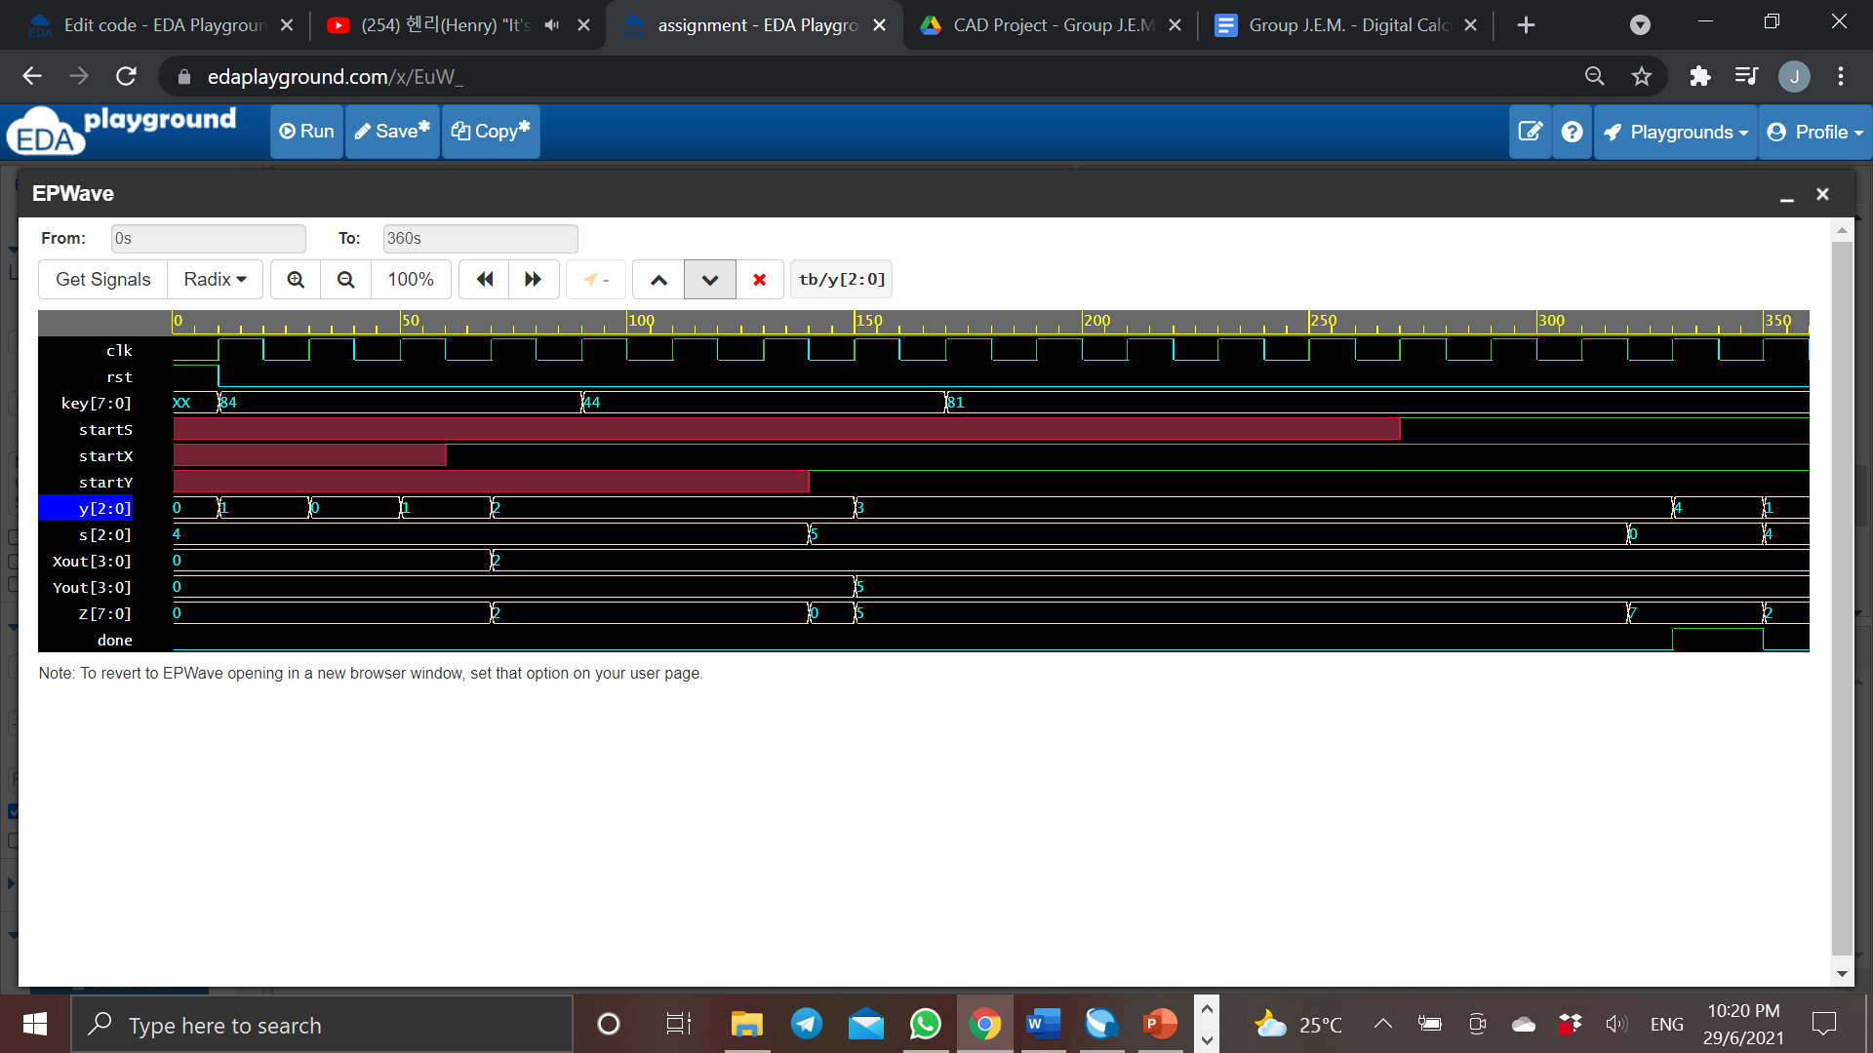

**RTL viewer of Top-Level Module (Digital Calculator)**

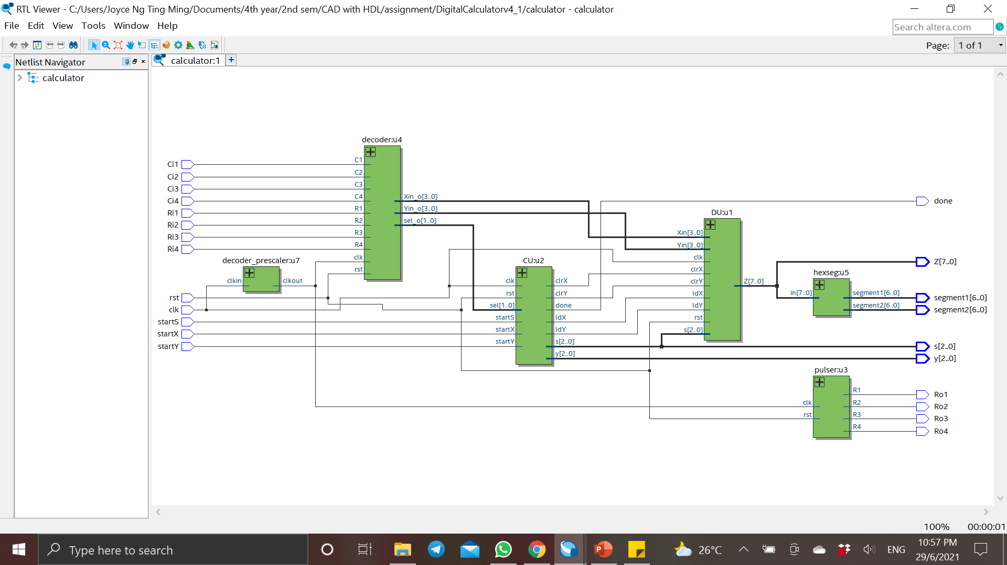

**Pin Planner**

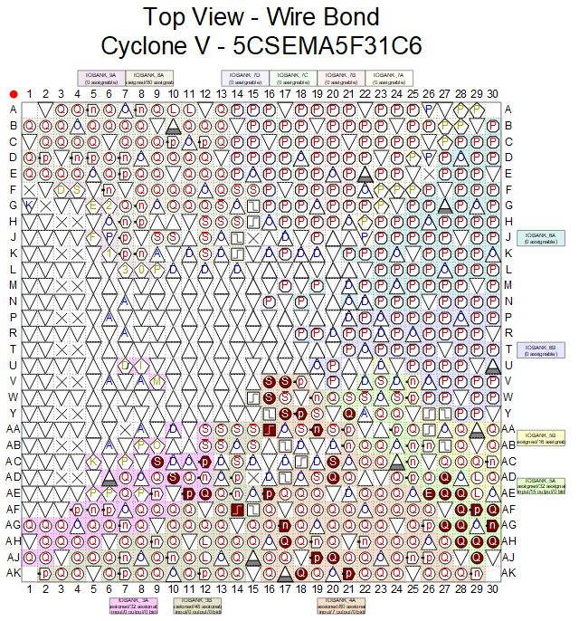

**Pin Planner**

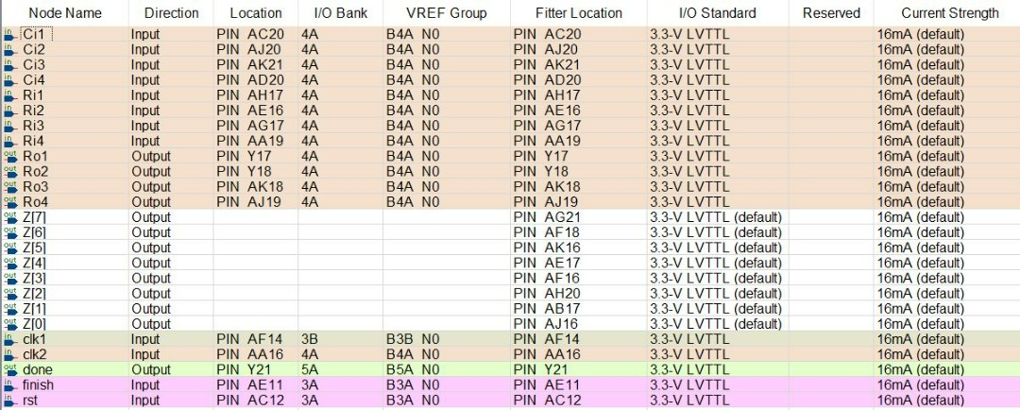

**Pin Planner**

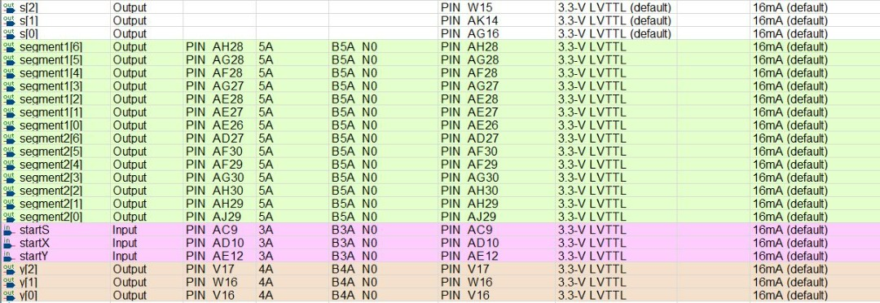

**Programmer**

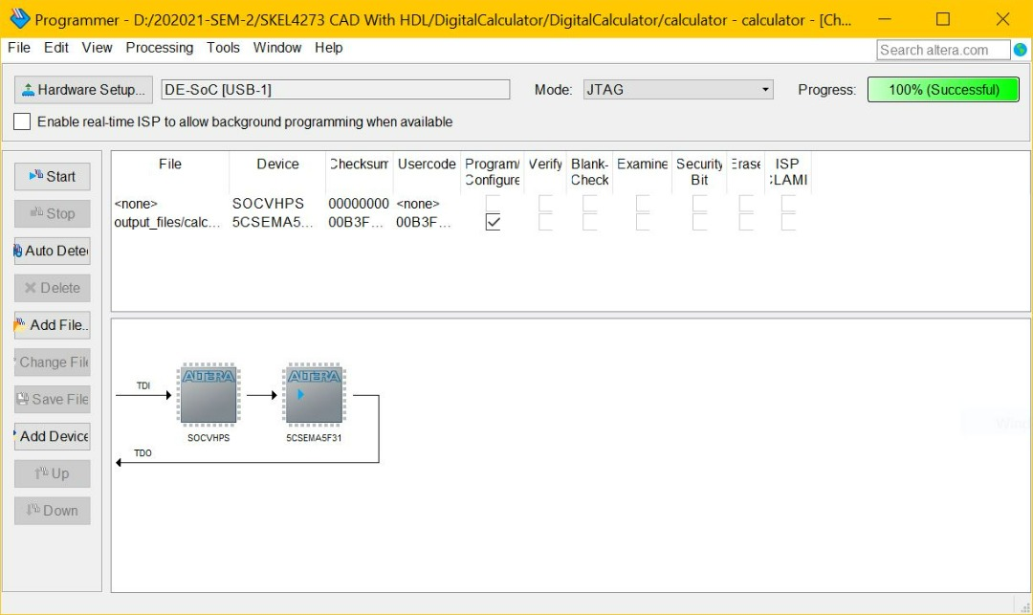

**Hardware Connection**

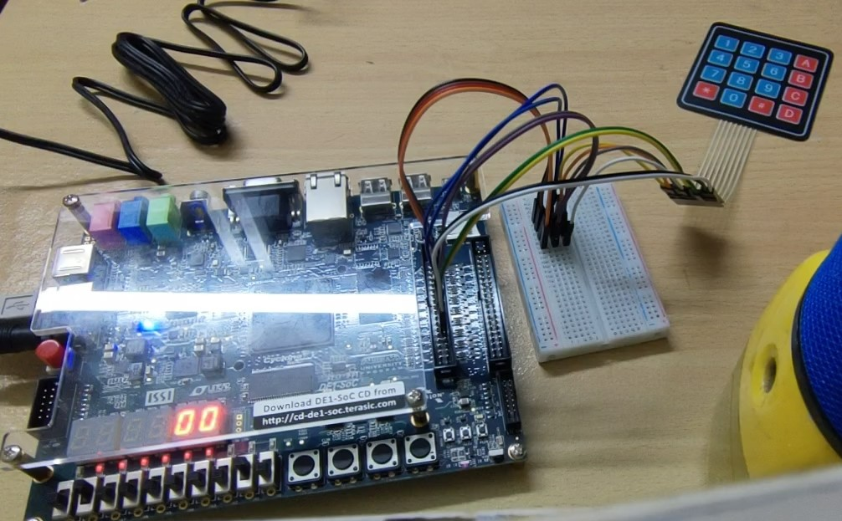

**Video demonstration link:**

[**https://youtu.be/hT2JrUVO6RM**](https://youtu.be/hT2JrUVO6RM)